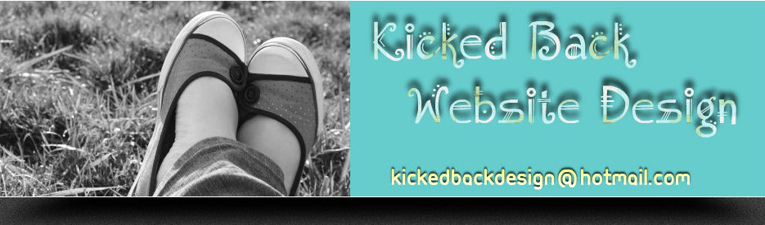

Kicked Back Website Design
http://kickedback.weebly.com
Website Set-up & Maintenance Plans

Legal Statement – Purchase Agreement
Refunds & Cancellations
You have 30 days after your final approval of your website(s) to cancel and receive a refund. No refunds will be issued after 30 days. Cancellations can result in the deletion of your website(s).
Purchase Application
Setup fees apply to one (1) completed website. Multiple domains require individual purchases of setup, domain, and/or maintenance fees. You may change domains at your own expense.
Payments, Failures, & Reinstatements
Failure to pay your monthly or yearly subscriptions within 14 days of the due date will result in suspension of your website(s). Reinstatement of said website(s) is available once full payment has been received and cleared.
Miscellaneous
Terms subject to change without notification. All terms are controlled by Kicked Back Website Design and its owners.
Updated 11/17/11

